**C:\Users\beth larkham\AppData\Local\Microsoft\Windows\Temporary Internet Files\Content.IE5\AW2Q2TVI\MC900250807[1].wmfC:\Users\beth larkham\AppData\Local\Microsoft\Windows\Temporary Internet Files\Content.IE5\AW2Q2TVI\MC900300902[1].wmf**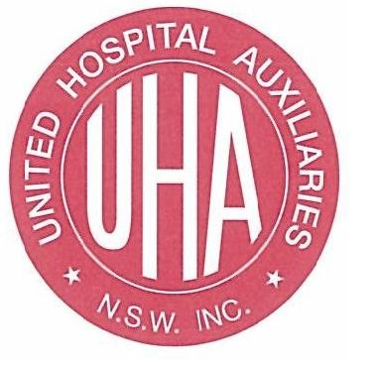

.

Classic Car, Classic Ford, 1920s, Original Art Print, FREE SHIPPING! Gift Idea VIntage Car Drawing Art Old Car illustration Print OLd Ford

TAMWORTH HOSPITAL

AUXILIARY

**will be holding**

**SOUP AND DAMPER LUNCHEON**

VARIETY OF HOMEMADE SOUPS AND DAMPERS

SWEETS, TEA AND COFFEE

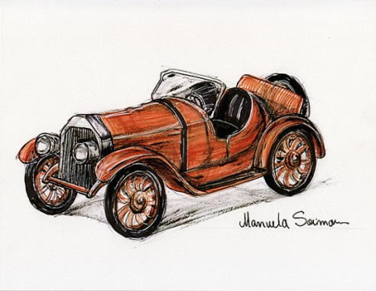 **SUNDAY JUNE 28TH**

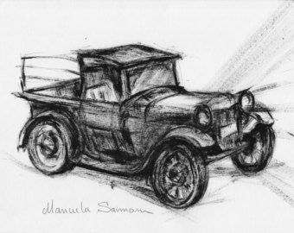 **12:00 NOON FOR 12:30 LUNCH**

AT

**DURI COMMUNITY HALL**

**DURI**

**TICKETS $15:00 each**

TRADING TABLE, RAFFLE, LUCKY DOOR PRIZES.

THERE WILL ALSO BE OLD CARS, CLASSIS CARS AND HOT RODS ON DISPLAY OUT THE FRONT OF THE HALL

COME ALONG AND SUPPORT THE TAMWORTH HOSPITAL AUXILIARY, WITH ALL THE PROCEEDS GOING TOWARDS THE PURCHASE OF EQUIPMENT FOR TAMWORTH HOSPITAL

**ENQUIRIES PLEASE RING MAUREEN SAMPSON ON 67659969 OR SALLY CRONBERGER ON 0410609583 .**